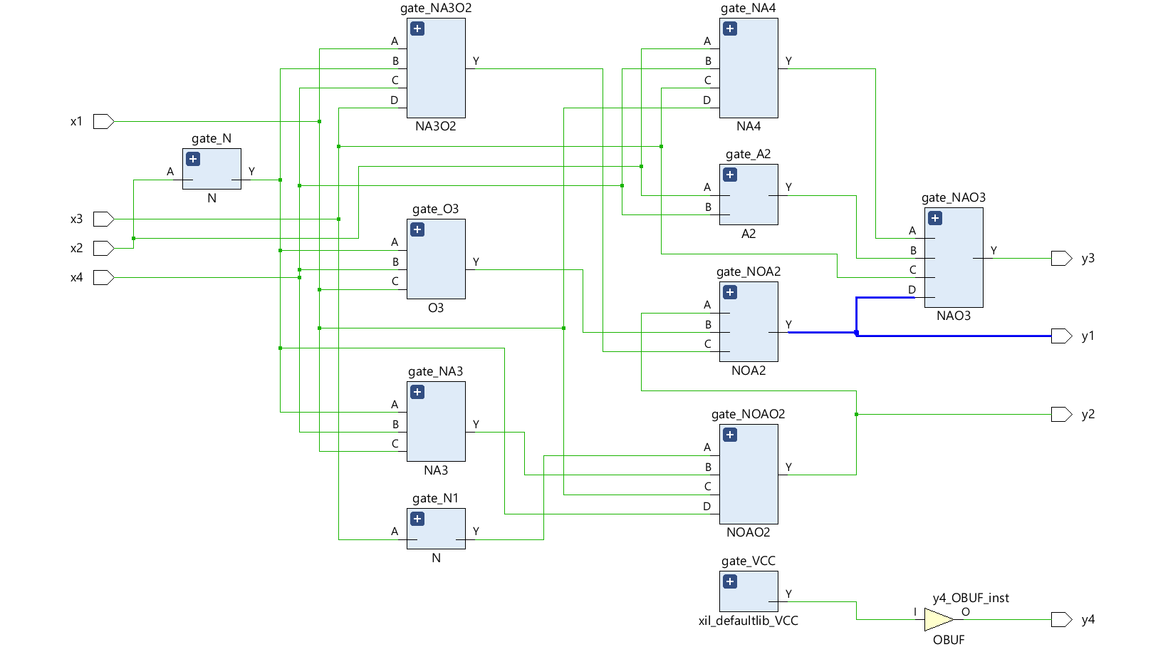

Таблица истинности
x1 | x2 | x3 | x4 | y1 | y2 | y3 | y4
0 | 0 | 0 | 0 | 0 | 0 | 1 | 1
0 | 0 | 0 | 1 | 0 | 0 | 1 | 1
0 | 0 | 1 | 0 | 0 | 0 | 0 | 1
0 | 0 | 1 | 1 | 0 | 0 | 0 | 1
0 | 1 | 0 | 0 | 0 | 1 | 1 | 1
0 | 1 | 0 | 1 | 0 | 1 | 0 | 1
0 | 1 | 1 | 0 | 0 | 1 | 0 | 1
0 | 1 | 1 | 1 | 0 | 1 | 0 | 1
1 | 0 | 0 | 0 | 0 | 0 | 1 | 1
1 | 0 | 0 | 1 | 1 | 0 | 0 | 1
1 | 0 | 1 | 0 | 1 | 0 | 0 | 1
1 | 0 | 1 | 1 | 0 | 1 | 0 | 1
1 | 1 | 0 | 0 | 0 | 0 | 1 | 1
1 | 1 | 0 | 1 | 0 | 0 | 0 | 1
1 | 1 | 1 | 0 | 0 | 0 | 0 | 1
1 | 1 | 1 | 1 | 0 | 0 | 1 | 1

Система логических функций

y1 = ( (x̄3 ∨ (x̄2·x4·x1)‾) · (x1 ∨ x̄2) ∨ (x̄2∨x4∨x1) · (x1·x̄2·(x4∨x3))‾ )‾

y2 = ( (x̄3 ∨ (x̄2·x4·x1)‾) · (x1 ∨ x̄2) )‾

y3 = ( (x2·x4·x3·x1)‾ · (x2·x4 ∨ x3 ∨ y1) )‾

y4 = 1

